Seen Music: Ambient Music Data Visualization

for Children with Hearing Impairments

**ABSTRACT**

In this paper, we propose a prototype of a music visualization system that captures and records the music component into digital data form, and display in visual features for children with hearing impairments. The analog sound data of music played physically is scaled into binary matrix and scalar values that could be used as data structures for transcribing into output. We designed a system detecting sound from physical violin, and then we demonstrate three physically visualized music information methods with ambient objects children see and interact in their everyday lives, as flowerpot, plants, and frame. We describe how the data captured from physical musical instruments can be seen throughout these objects with variations, and suggest future possibilities of interactive music visualization library for music education in classroom for children with hearing impairments.

**Categories and Subject Descriptors**

D.2.2. [**Software Engineering**]: Design Tools and Techniques-Evolutionary Prototyping, Modules and Interfaces, User Interfaces; H.5.2. [**Information Interfaces and Representation**]: User interfaces-Interaction styles, User-centered design, J.5. [**Computer Applications]:** Arts and Humanities-Performing Arts.

**General Terms**

Human Factors, Design

**Keywords**

Music Visualization, Music Education, Assistive Technology

# INTRODUCTION

Permission to make digital or hard copies of all or part of this work for personal or classroom use is granted without fee provided that copies are not made or distributed for profit or commercial advantage and that copies bear this notice and the full citation on the first page. To copy otherwise, or republish, to post on servers or to redistribute to lists, requires prior specific permission and/or a fee.

*Conference’10*, Month 1–2, 2010, City, State, Country.

Copyright 2010 ACM 1-58113-000-0/00/0010 …$15.00.

Since music has taken a significant role to relieve stress, to understand beauty, and to develop empathy skills, it has been taught in classroom for early childhood [7]. Understanding component of music, melody, harmony, and rhythm, is the main theme of music education in classroom. Although many researchers and interaction designer have thought computer added tool for early childhood music education, because of unique property of music itself, teaching music for education purpose is not intentionally easy for teachers of children with hearing impairments, who are not able to listen melody. Only limited parts of music was felt by kids having hearing defect, such as feeling beats by vibration. We suggest a system that integrates the process of recording physical music, interpreting music data, and translating it into visible form.

|  |
| --- |
|  |

Figure 1. Playing violin with Seen Music system to capture components of music sound

Our design goal includes four main considerations:

* **Capturing physical music sound in digital format:** There are several ways available of recording analog music data, and interpreting it into digital form using signal processing. To reduce process, we design system to directly capture digitized format of sound, and save in the least amount of data structure.
* **Cost effective rapid prototyping:** Integrating many delicate sensors will enable the preciseness of captured music data. However, keeping system as simple and cheap as possible allows general public to use the proposed design widely in classroom at school of deaf students.
* **Visualize music with tangibles:** Feeling music with all possible senses is highly recommended for music education. Although the main goal of the system is visualizing sound for children with hearing impairments, we design information visualization tangible and tactile, enriching music experience, so that benefit will reach to general children.
* **Time effective differentiation on visualization:** With the least amount time required, our system provides fluent differentiation of patterns of visualization, encouraging users to free transform and customization of visualization.

# BACKGROUND

## Music Education for Children Who Need Special Help

Music used to be educated for building emotional sympathy skills at early childhood in classroom. However, for children with hearing impairments, it is challenging to teach the concept of melody and rhythm that consist of music, basically based on sound.

We conducted casual semi-interviews with teachers at school of deaf students, to understand how the music has been taught for children with hearing impairments. There are limited, but some ways to enable children feel the music. The easies way is signing lyrics of songs in ASL[1], but in this way, it is almost impossible to present pitch and tune. Teachers also used large drums or speakers so children can put their hands on it to feel the vibrations. They also has been using video format to “show” the degree of music, and recently, started to use sound reactive music light to express component of music in visualized means. As another possible way, one of schools for deaf students is building a vibrating floor, having a raised portion of floor that has air flow and a few large speakers that play the music beneath it, so that the floor will vibrate along with the music.

Similarly, Hyundai-car released a recently invented *Touchable Music Seat* for cars to enable people with hearing impairments to feel the music while driving, and several samples were installed in classroom [5]. For those who cannot listen to the sound, the seat provides precise vibration based on the music beats to whom sitting in the car. However, the question left unanswered, how *Melody* and *timbre* of music will be delivered with rhythm at the same time?

## Sound Visualization

Visualization of music has been a rising interests among practitioners, educators, artists, and researchers. The equalizer (Figure 2, left) is the most common and accessible form to show how tune and rhythm of music progress over time, with various colors of lines representing pitch, with different height and gap of each peaks by lines representing frequencies and amplitude. Installation artists used series of LEDs, motors, and sensors to visualize component of music, for example, the form of “Dancing Water Fountain” as shown in Figure 2 (right). With appropriate mapping from music note to the combinations of colors and movements, melody of music can be efficiently delivered to children with hearing problems, while the frequency of color change and movements changed represents rhythms.

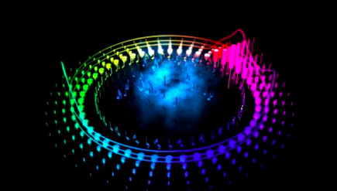 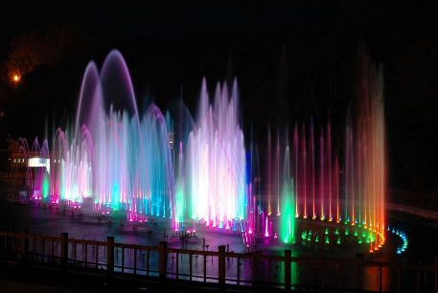

Figure 2. As various form of equalizer visualizes music in vivid colors and geometries (left), dancing fountain was also used to visualize music with direction and height of water released and colors reflected into splash (right).

## Tangibles for Information Display

Last year, *Muzlog* presented how the sound of the physical instruments can be captured in digital format, by recording pitch and stroke into music note. It is a good start to record analog melody to readable digital form, in order to be visualized [6]. Early *Noteput* project explored tangibles, which is actually visible representing meaning itself as note, to compose and play music on the screen interactively [3]. Putting physical notes on empty digital manuscript projected the tabletop interface enabled recognizing music by the controller automatically. Meanwhile, *Laughter Blossom* presented the artificial flower that interacts with people in ambient form of information display. [11] It proposed a daily life tangible to represent laughter “sound” in visual form, blossoming the flower. In this way, they opened a possibility for how natural phenomenon represents music. Laughter blossom was originally inspired by *LaughingLily*, the novel method to use flower as information visualization [1] With various factors affect the appearance of flower, such as numbers of flower, shape of petals, colors, the level of blooming, etc., flower was successful form of expressing data. Another example of information display with ambient objects was *Infortropism* [4]. The plant’s leaves as interactive tangible that projects density of light in surrounded environments by being naturally installed in a space, from the direction of leaning, and the degree of bent.

However, designed interactions on tangibles by *Muzlog* system and *Noteput* project were limited into input of music, failed to let children with hearing impairments enjoy as output. We expect combinations of (1) information visualization strategies by daily life objects children always see around, and (2) interactive tangibles for capturing music sound will empower them to learn and feel music in classroom.

# IMPLEMENTATION

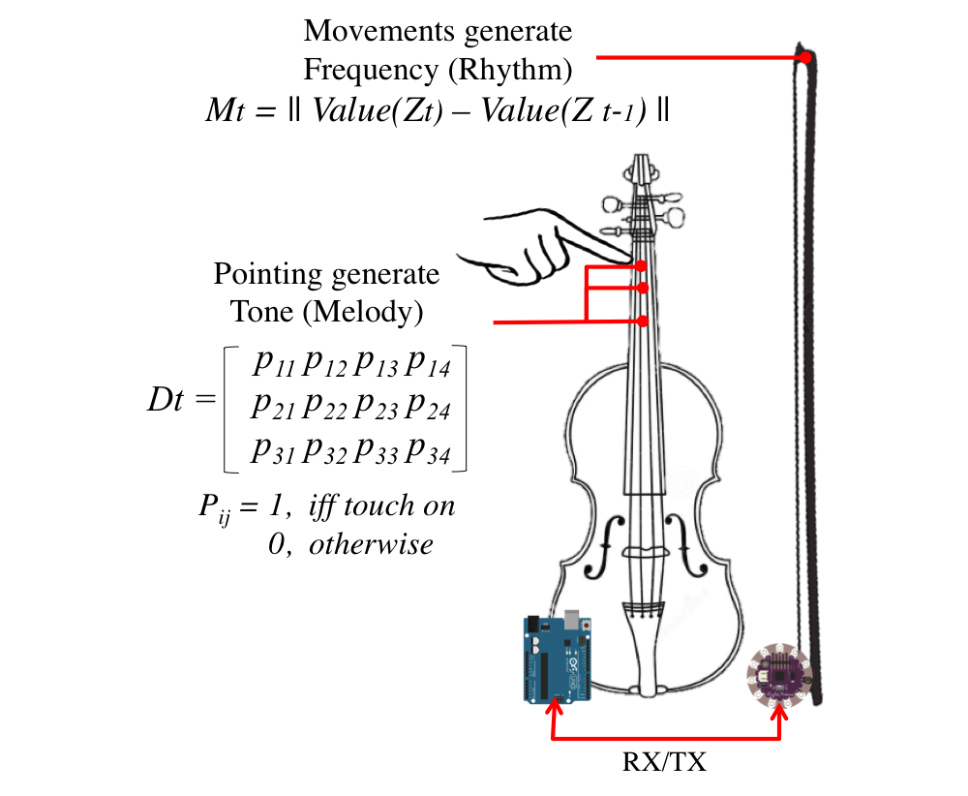

Figure 3. Music data (Rhythms and Melody) generation and data schema to transfer into music visualization system

Our system consists of two modules, capturing physical music data and interpreting this into ambient display. We examined flow of the system by combining violin performance and three example applications of information display. The software application programmed in sketch [2] has detection of violin sound as common part, and three different output mode, (1) analog ranged (0 ~ 180°) output into one servo for flower, (2) binary ranged (High/Low) output into one vibration motor for plant pot, and also (3) binary ranged output into six LEDs. Main Arduino board that connects to the output pins receives data that sent from LilyPad, which is the second controller gets sensor values from an accelerometer, via customized communication socket between them, as described in Figure 3.

## Collecting Physically Played Music Data

Transcribing physically played music into digital form is neither easy nor simple process, needing a special system to interpret it. For example, to avoid noise, a musician should play instruments in soundproof room, it also requires signal processing to interpret components of music since recorded music is still an analog data. Not only that, the analogue frequency and amplitude should be interpreted into integer, in order to be digitized. To ease this process without complex computer system by capturing natural music sound from traditional musical instruments, we designed a circuit for capturing touch signal, which is attachable on almost any kinds of musical instruments. With the violin example, we designed the proper data structure to record data as shown in Figure 3. As a violinist touches fingerboard to generate chords while playing, we applied cooper tape circuits that will be closed by the finger touch between ground and signal. Finger touch on the violin neck with circuits attached will trigger changes of the resistances, so can send this resistance value as an input signal of that position. Arduino board is attached to the back of body. Since the fingerboard only generates the different level of tune, we also attached an accelerometer to the tip of a bow, as it moves the most dramatically while playing, and an Lilypad on the bottom get Z-movement sensor value from the accelerometer. These two controllers are connected by wires, as we worried the bow will be heavy if we additionally apply Xbee shield and modules on it.

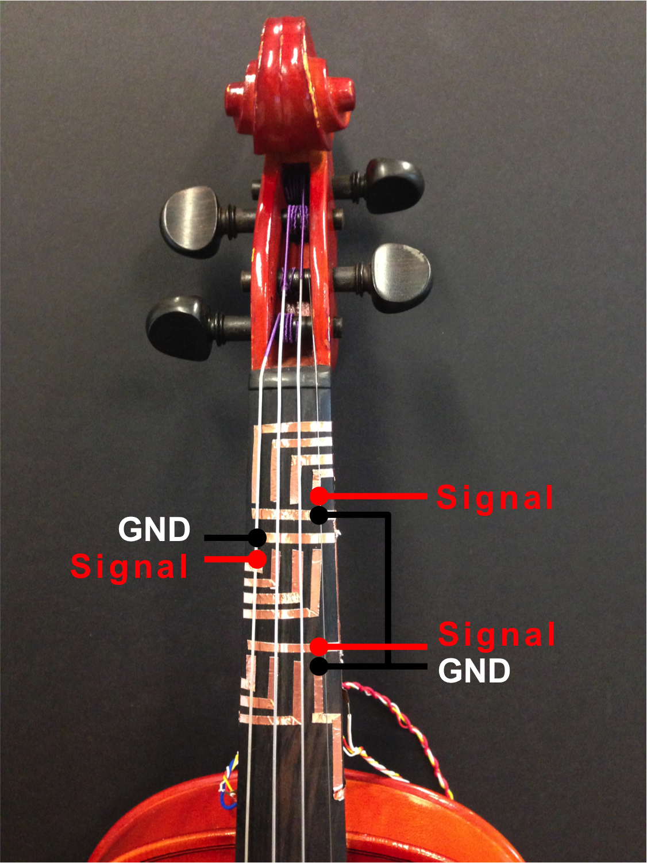 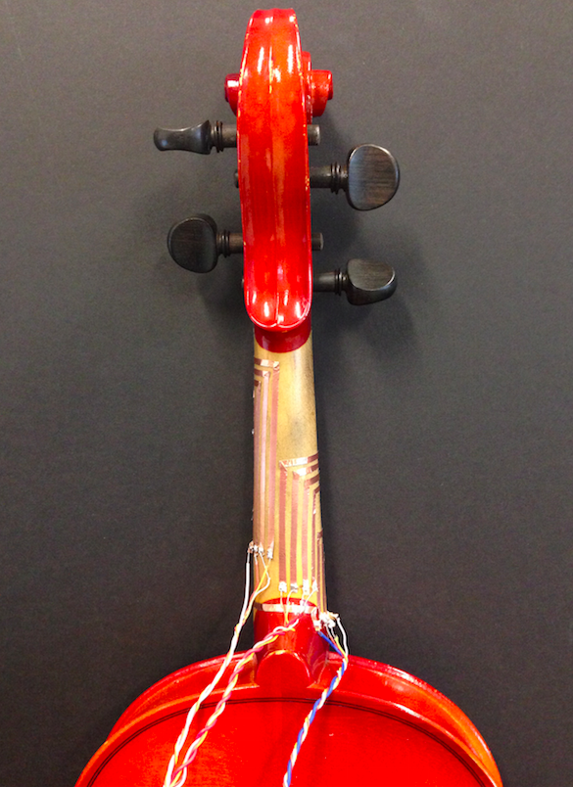 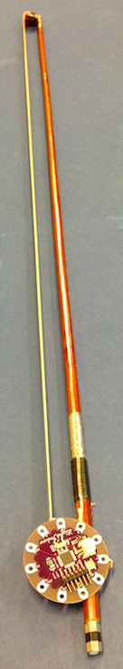

Figure 4. Initial settings for detecting tone of violin play. Each of three positions on the fingerboard has four digital input by four strings, closed the circuit by grounding finger touch.

## Musical Data Visualization

Our goal is projecting music data into ambient visualization that could interpret the athletic of music itself. As people listen to music anywhere, anytime, with anything (CD player, smartphone, Radio, etc.), we hope children to listen and enjoy music with anything they see not only in classroom, but also from daily lives. Now we propose three types of different music data visualization mode.

*Blooming Flower*

Based on the kind of objects, different form of mapping can be realized. Laughter flower and Laughing Lily inspired us to design a flower blossoming by servo, synchronized by the violin playing. The degree of flower blossom is mapped to the servo’s rotation degrees from 0 to 180°, which is transcribed data of tune from string input. As we planted three flowers with one servo in a pot, every 60° were assigned to one position on the fingerboard, and 15° to four strings’. Each of flowers were tackled to the different tip side of rotating axe of the servo pivot, enabling movements direction of both case could be inversed. The speed normalized in scale, and sent to motor to direct speed. The degrees that motor rotates are simply calculated by passing position of data in the Dt matrix over time as parameter to data mapping function. This is possible by turning off lower input to 0 when more than one finger position is detected, since pointing with two finger pointing second position with middle finger generates same sound with positioning both of index and middle finger at the same time.

for (rows = 1:3, cols = 1:4) in Dt

Servo.write( rows*60 + cols*15);

LED(rows, HIGH);

delay(Mt);

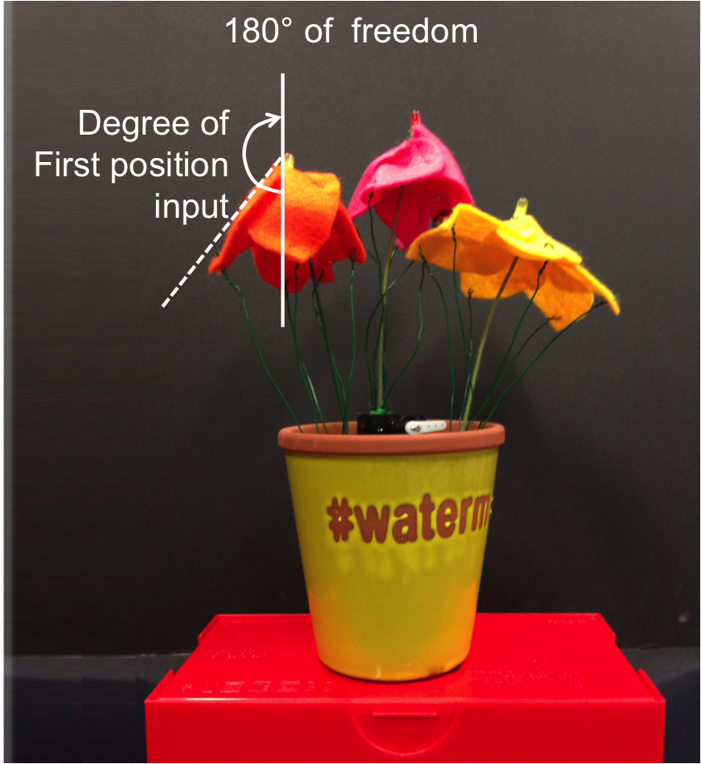 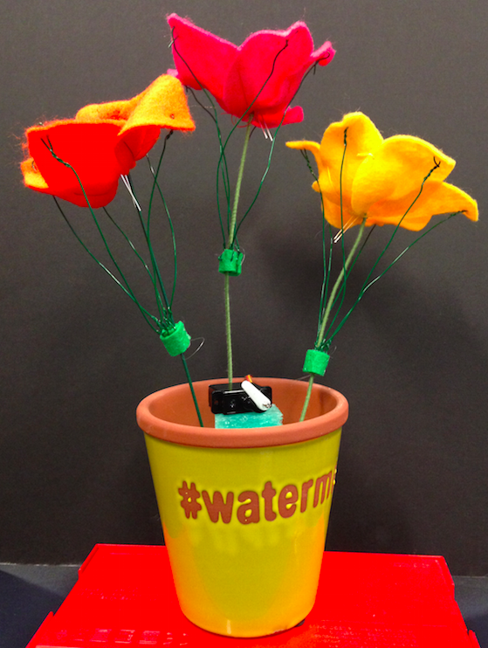

Figure 5. Blossom’s petals move up and downs by servo in horizontal direction, stating from blooming or closing.

If we opt three motors, assigning each per flower, it can be also individually mapped to each three position, empowering flowers blooms in larger degrees. LEDs that embedded into stamen of flower center is also able to show some degree of data, by light on/off, or gradully dimming to represent how long the sound will sustain.

*Waving plants*

The direction of plants it leans and/or rough degree of bent could also demonstrate data. We attached pairs of leaves to several horizontal axes that will be connected to servo pivot. Since the axes are attached to leaves by Velcro tapes, users can also choose numbers and positions of leaves stick to it, to differentiate movement patterns. Since the servo could rotate up to 180°, these axes tackle for triggering leaning in left and right direction, or with enough high speed, it could continuously vibrate.

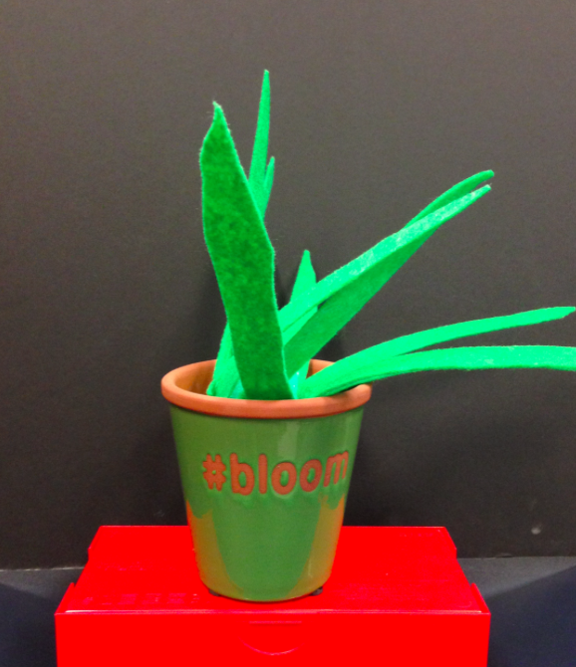 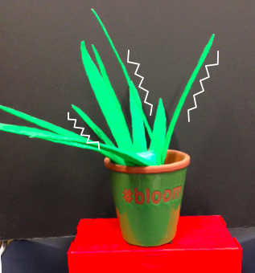

Figure 6. Waving plants that indicated melodies and rhythm. If user turns the state of plant off to binary, it simply vibrates over time while music plays.

*Colored Frame*

The window reflecting sunlight is one of the most common *objet* found around children. Inspired by stained glass, we similarly designed two types of transparent table frames, with laser engraved (Figure 7, left), and cut shaped pattern (Figure 8, right). Frame of picture replace athletics of music as a good synonym of Arts. For 12 signal of strings input, we assigned six different colored digital LEDs. As music proceed slow, previously turned on LED sustains while the other triggered on too, results in two or more combined colors are projected into frame, enabling more variations of color patterns.

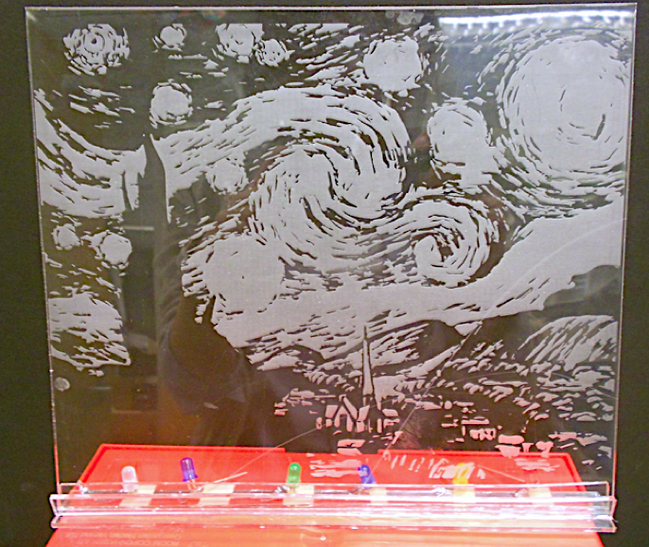 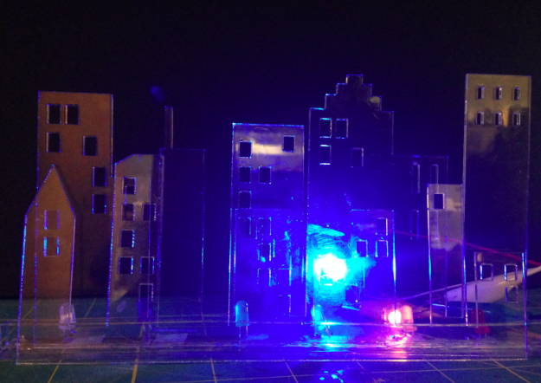

Figure 7. Laser engraved pattern of “*Stary stary night*” with six LEDs installed into standing slot (left), and a laser cut frame of city skyline with blue and orange color LEDs enabled (right)

The output board simply projects colors by serialized array of LEDs and dims with delays, while period of dimming shows how long the lasting sound sustains. We used a transparent acrylic sheet, so that it reflects LEDs’ lights of backside circuit through front view. Engraved are and cut edge refract lights, creating more salient features distinguished, and also tangible since this is a concave relief at the same time.

|  |  |  |  |  |  |  |
| --- | --- | --- | --- | --- | --- | --- |
| LED | White | Violet | Green | Blue | Yellow | Red |
| Trigger | *p11, p31* | *p12, p32* | *p13, p33* | *p21, p11* | *p22, p12* | *p23, p13* |

Table 1. LEDs assigned to 12 inputs

# DISCUSSION

Our prototype could be applied to other musical instruments that trigger sound by push or touch, such as Flute or Piano. And benefit of visualization will reach to early stage childhood music education generally. However, the physical visualizations are not as precise as screen output, but these objects make *natural* movements. This could be benefit especially for children for developing emotional empathy, but at the same time, this also could be limitation of data visualization. This rapid prototype of music capturing and visualization system’s data mapping is simple, not as affluent as the actual music. This is the trade off between cost and delicacy. For example, the chords of open strings are not able to be captured, because our system needs at least one grounded position on fingerboard as input signal. This could be replaced the 4th position of previous string, but to guarantee freedom of performer, we should consider the default input per strings. This could be realized by applying cordUIs [9] into strings, recognizing stretched level of strings by stretch sensor. The more sensors, the more output signals will enrich the detail of visualization, but it costs more, and possibly increase the stress level by information overflow.

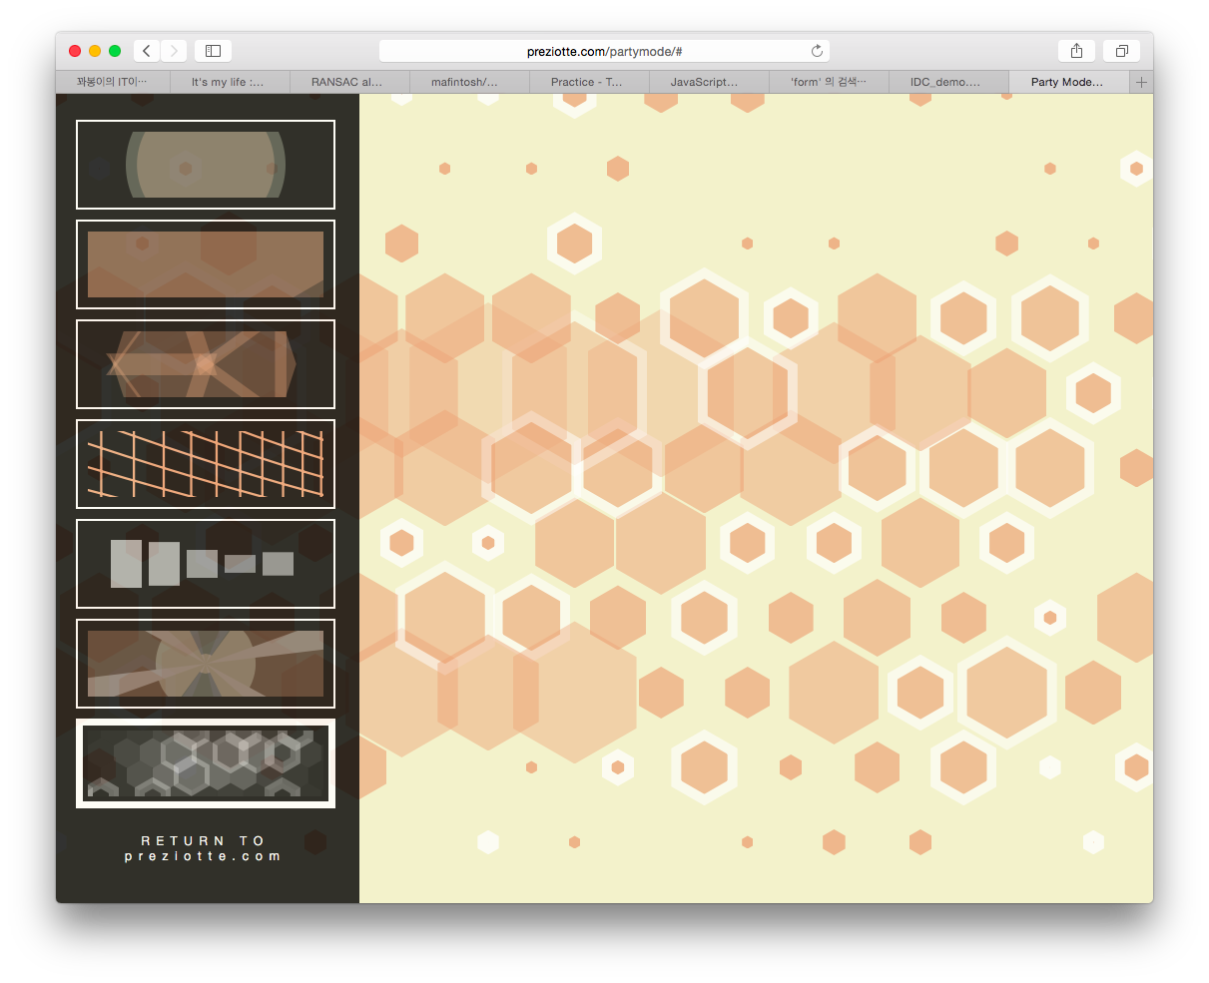 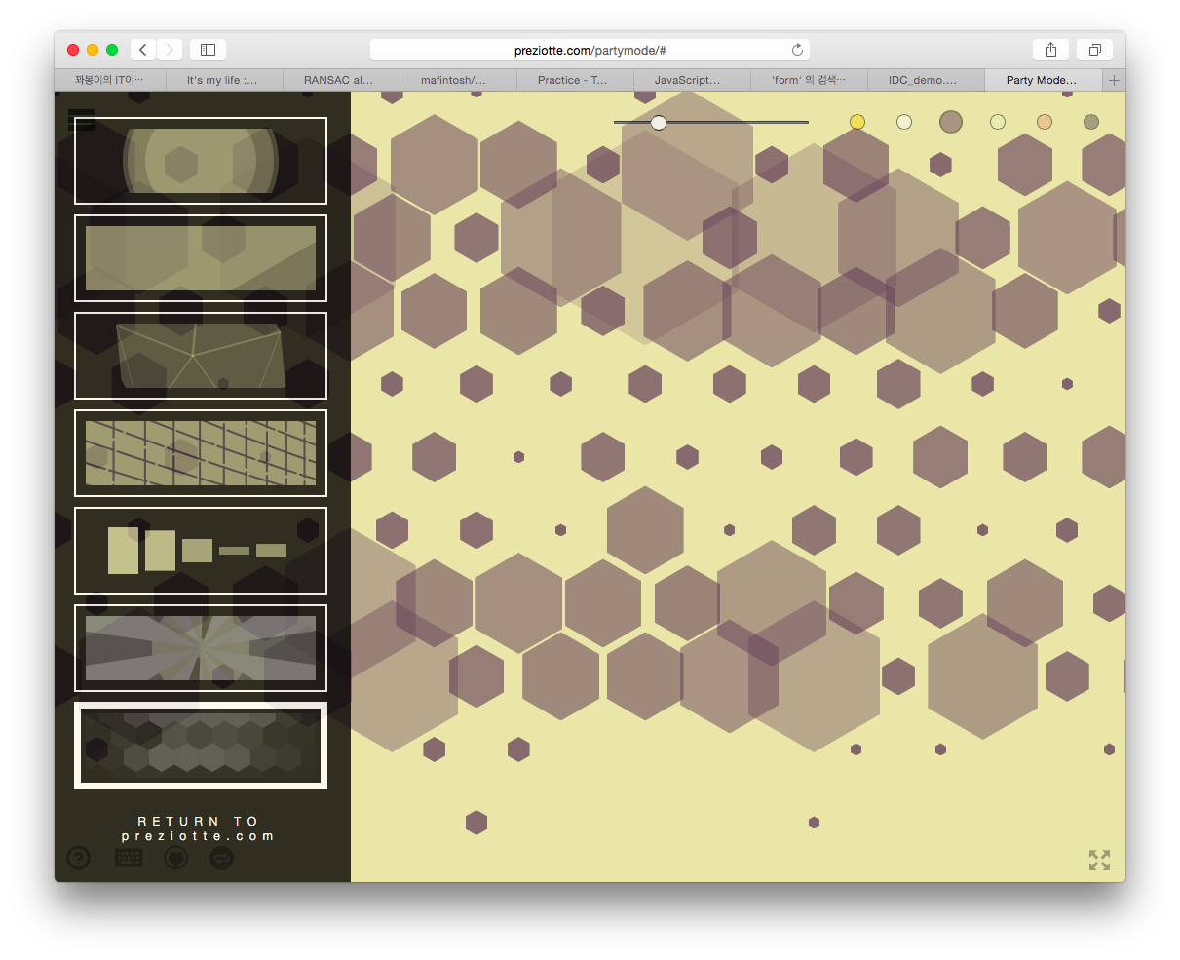

**Figure 8**. Pentagon Geometry pattern mode at *PartyMode* CSS Library that visualizes music

For future works, we also need a user test in cognitive level, if different patterns of visualization really felt or, efficiently recognized by children with hearing impairments. Also, we are considering building CSS visualization library, which is generally applicable any screen in classroom. Figure 8 shows a *Partymode* library that reads music data and represents it into colors, size, arrangement of different patterns of geometries. [8] To enlarge children’s interests into music, we possibly design the game character that reacts on the music played by instruments.

# REFERENCES

1. Antifakos, S., and Schiele, B. *LaughingLily:* *Using a Flower as a Real World Information Display.* In proc. *Ubicomp’03*
2. Arduion. <http://arduino.cc>
3. Heuer, J. F, *Noteput* <http://www.jonasheuer.de/index.php/noteput/>
4. Holstius, D., Kembel, J., Hurst, A., Wan, P., and Forlizzi, J. 2004. Infotropism: living and robotic plants as interactive displays. In *Proceedings of the 5th conference on Designing interactive systems: processes, practices, methods, and techniques (DIS '04).* ACM, New York, NY, USA, 215-221. DOI=10.1145/1013115.1013145 http://doi.acm.org/10.1145/1013115.1013145
5. Hyundai Car, *Sonata Touchable Music Seat* <https://vimeo.com/65620958>
6. Kim, H., and Nam, T-J., Muzlog: *Instance Music Transcribing System for Acoustic Guitrarists,* In Proc. Extended Abstraction CHI’14, ACM Press
7. Mckinnon, I., (2005) *Children’s Music Journey: The Development of an Interactive Software Solution for Early Childhood Music Education.* Computers in Entertainment (CIE), Vol.3. Issue 4.
8. Preziotte M., *Party mode* <https://github.com/preziotte/party-mode>
9. Schwarz, J., Harrison, C., Hudson S., and Mankoff, J. Cord input: an intuitive, high-accuracy, multi-degree-of-freedom input method for mobile devices. In *Proceedings of the SIGCHI Conference on Human Factors in Computing Systems (CHI '10)*. ACM, New York, NY, USA, 1657-1660. DOI=10.1145/1753326.1753573 http://doi.acm.org/10.1145/1753326.1753573
10. Wisneski, C., Ishii, H., Dahley, A., Gorbet, M., Brave, S., Ullmer, B., and Yarin, P. 1998. Ambient Displays: Turning Architectural Space into an Interface between People and Digital Information. In *Proceedings of the First International Workshop on Cooperative Buildings, Integrating Information, Organization, and Architecture (CoBuild '98),* Norbert A. Streitz, Shin'ichi Konomi, and Heinz Jürgen Burkhardt (Eds.). Springer-Verlag, London, UK, UK, 22-32.
11. Yoon, S., Lee, Y, Nam, T, Lee, K *Laughter Blossom: A Prototype of Laughter Interaction Design*, In Proc. *IASDR’13*
12. Zhang, C., Shen, L., Wang, D., Tian, F., Wang, H. 2011. CoolMag: a tangible interaction tool to customize instruments for children in music education. In *Proceedings of the 13th international conference on Ubiquitous computing (UbiComp '11)*. ACM, New York, NY, USA, 581-582. DOI=10.1145/2030112.2030223 http://doi.acm.org/10.1145/2030112.2030223*.*

1. American Sign Language